Noakhali Science & Technology University  
Sonapur, Noakhali – 3814

PROJECT:

Design & Development of Daily Tasks

Submitted to

**Dr. Md. Kamal Uddin**

Associate Professor

Department of Computer Science & Telecommunication Engineering,

Noakhali Science & Technology University.

Submitted by

Mohammad Borhan Uddin

ID: ASH2101008M

Sahadat Hossain

ID: MUH2101034M

Project Title: Design & Development of Daily Tasks

**Introduction:**

“Daily Tasks” is a Java Swing application meticulously crafted to enhance daily productivity. Effortlessly manage tasks, mark them as completed or removed. Besides, it can track the progress and show how many tasks and how many of them are completed.

**Programming Language:**

Java

**Library:**

Swing, AWT

**Learning Objectives:**

The learning objectives include mastering Java for GUI development using Swing and AWT libraries, understanding user requirements, implementing task management features, and applying object-oriented principles effectively.

**Design:**

Utilizing Java Swing and AWT libraries, the project offers a user-friendly graphical interface for seamless task management. The design prioritizes simplicity and ease of use, ensuring an intuitive experience for users of all levels. More precisely, we have focused on making it more simple and neat design to use. Users can see his progress rate which may help him to be punctual.

**Analysis:**

Through careful analysis of user needs and requirements, the project aims to address common challenges faced in task management. By offering features such as task addition, completion or deleting tracking, and progress visualization, the system enhances user productivity and organization.

**Features:**

1. Task Addition: Users can easily add new tasks to their list.
2. Task Completion/Deletion: Tasks can be marked as done/deleted.
3. Progress Tracking: The system enables users to visualize their progress by displaying the number of completed tasks.
4. Error handling: All possible errors such as empty text field has been handled carefully.
5. User-Friendly Interface: The graphical user interface offers a seamless and intuitive experience for users.

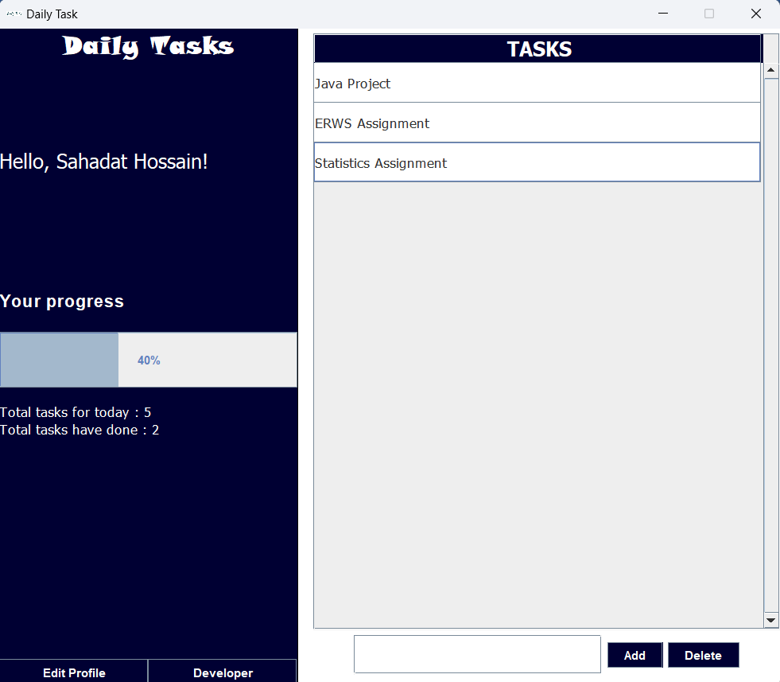

Figure 1 : The interface of "Daily Tasks" Application

**Implementation:**

Github: <https://github.com/borhan008/dailytask>

Live Preview on Youtube: http://gg.gg/dailytasks / https://youtu.be/7XBMlHLvIuk

**Conclusion:**

In conclusion, the "Daily Tasks" project provides a robust solution for effective task management. Its user-centric design, coupled with a range of features, makes it a valuable tool for individuals seeking to streamline their daily routines and boost productivity.

**Implementation:**

import java.awt.*;

import java.awt.event.*;

import javax.swing.*;

import javax.swing.table.*;

import javax.swing.tree.DefaultMutableTreeNode;

public class DailyTask extends JFrame implements ActionListener{

    String data[][] = {};

    JButton add;

    JTextField txtfield;

    JButton delete;

    JButton editBtn;

    JButton devBtn;

    String user = "User";

    JLabel ptext2;

    JLabel name;

    JProgressBar bar = new JProgressBar();

    int totwork = 0, totdone = 0;

    String col[] = {"TASKS"};

    JTable table = new JTable(data,col);

    DefaultTableModel tableModel = new DefaultTableModel(data, col) {

        @Override

        public boolean isCellEditable(int row, int column) {

           return false;

        }

    };

    DailyTask(){

        System.out.println((byte)'c');

        this.setSize(800, 700);

        this.setDefaultCloseOperation(this.EXIT_ON_CLOSE);

        this.setResizable(false);

        this.setTitle("Daily Task");

        this.setLayout(null);

        ImageIcon img = new ImageIcon("logo.png");

        this.setIconImage(img.getImage());

        bar.setValue(0);

        bar.setStringPainted(true);

        JPanel leftCol = new JPanel();

        JLabel logo = new JLabel("Daily Tasks");

        leftCol.setBounds(0,0, 300, 660);

        leftCol.setLayout(new BorderLayout(5,10));

        leftCol.setBackground(Color.WHITE);

        logo.setFont(new Font("Snap ITC", Font.BOLD, 25));

        logo.setOpaque(true);

        logo.setForeground(Color.white);

        logo.setVerticalAlignment(JLabel.CENTER);

        logo.setHorizontalAlignment(JLabel.CENTER);

        leftCol.add(logo, BorderLayout.NORTH);

        JPanel leftCenter = new JPanel();

        leftCenter.setLayout(new GridLayout(3,1, 20, 20));

        name = new JLabel("Hello, " + user + " !");

        name.setFont(new Font("Tahoma", Font.PLAIN, 20));

        name.setForeground(Color.white);

        leftCenter.add(name);

        leftCenter.setBackground(new Color(0xFFFFFF));

        JPanel progressPanel = new JPanel(new GridLayout(3,1,5,5));

        JLabel ptext = new JLabel("<html><h2>Your progress</h2></html>");

        ptext2 = new JLabel("<html>Total tasks for today : " + totwork + "<br/>Total tasks have done : " + totdone + "</html>");

        ptext2.setFont(new Font("Tahoma", Font.PLAIN, 14));

        ptext.setForeground(Color.white);

        ptext2.setForeground(Color.white);

        progressPanel.add(ptext);

        progressPanel.add(bar);

        progressPanel.add(ptext2);

        leftCol.setBackground(new Color(0x000033));

        logo.setBackground(new Color(0x000033));

        leftCenter.setBackground(new Color(0x000033));

        progressPanel.setBackground(new Color(0x000033));

        leftCenter.add(progressPanel);

        leftCol.add(leftCenter, BorderLayout.CENTER);

        JPanel leftBtn = new JPanel();

        leftBtn.setLayout(new GridLayout(1, 2));

        leftBtn.setBackground(new Color(255, 255, 255));

*//leftBtn.setSize(new Dimension(100, 100));*

        editBtn = new JButton("Edit Profile");

        editBtn.addActionListener(this);

        editBtn.setFocusable(false);

        editBtn.setBackground(new Color(0x000033));

        editBtn.setForeground(Color.white);

        leftBtn.add(editBtn);

        devBtn = new JButton("Developer");

        devBtn.addActionListener(this);

        devBtn.setFocusable(false);

        devBtn.setBackground(new Color(0x000033));

        devBtn.setForeground(Color.white);

        leftBtn.add(devBtn);

        leftCol.add(leftBtn, BorderLayout.SOUTH);

        this.add(leftCol);

*// Right Column*

        JPanel rightCol = new JPanel();

        rightCol.setBackground(Color.WHITE);

        rightCol.setBounds(301, 0, 500, 660);

        JPanel panel = new JPanel();

        table.setAutoResizeMode(JTable.AUTO_RESIZE_OFF);

        table.setModel(tableModel);

        table.getColumnModel().getColumn(0).setPreferredWidth(450);

        table.setRowHeight(40);

        JTableHeader header = table.getTableHeader();

        header.setBackground(new Color(0x000033));

        header.setForeground(Color.white);

        header.setFont(new Font("Tahoma", Font.BOLD, 20));

        JScrollPane pane = new JScrollPane(table);

        pane.setPreferredSize(new Dimension(470, 600));

        pane.setVerticalScrollBarPolicy(JScrollPane.VERTICAL_SCROLLBAR_ALWAYS);

        table.setFont(new Font("Tahoma", Font.PLAIN, 14));

        panel.add(pane);

        rightCol.add(pane);

        JPanel rightBottom = new JPanel();

        rightBottom.setLayout(new BoxLayout(this, BoxLayout.X_AXIS));

        txtfield = new JTextField();

        txtfield.setPreferredSize(new Dimension(250, 40));

        add = new JButton("Add");

        add.setFocusable(false);

        add.addActionListener(this);

        add.setBackground(new Color(0x000033));

        add.setForeground(Color.white);

        delete = new JButton("Delete");

        delete.setFocusable(false);

        delete.addActionListener(this);

        delete.setBackground(new Color(0x000033));

        delete.setForeground(Color.white);

        rightCol.add(txtfield);

        rightCol.add(add);

        rightCol.add(delete);

        this.add(rightCol);

        this.getContentPane().setBackground(new Color(0, 0, 0));

        this.setVisible(true);

    }

    public void actionPerformed(ActionEvent e) {

        if(e.getSource() == add) {

            if(txtfield.getText().trim().length() > 0) {

                tableModel.addRow(new Object[] {txtfield.getText()});

                txtfield.setText("");

                totwork++;

                int y = totdone*100/Math.max(totwork, 1);

                bar.setValue(y);

                ptext2.setText("<html>Total tasks for today : " + totwork + "<br/>Total tasks have done : " + totdone + "</html>");

            } else {

                txtfield.setText("");

                JOptionPane.showMessageDialog(null, "The task field is empty.", "Error", JOptionPane.ERROR_MESSAGE);

            }

        }

        if(e.getSource() == delete) {

            if(table.getSelectedRow() != -1) {

                int chk = JOptionPane.showConfirmDialog(null, "Are you want to delete the task \"" + table.getValueAt(table.getSelectedRow(), table.getSelectedColumn()) + "\" ?");

                if(chk==0) {

                tableModel.removeRow(table.getSelectedRow());

                totdone++;

                bar.setValue(totdone*100/totwork);

                ptext2.setText("<html>Total tasks for today : " + totwork + "<br/>Total tasks have done : " + totdone + "</html>");

                }

            } else {

                JOptionPane.showMessageDialog(null, "Select the task first.", "Error", JOptionPane.ERROR_MESSAGE);

            }

        }

        if(e.getSource() == editBtn) {

            user = JOptionPane.showInputDialog("Name");

            if(user != null && user.trim().length() > 0)

            name.setText("Hello, " + user + "!");

        }

        if(e.getSource() == devBtn) {

            JOptionPane.showMessageDialog(null, "Mohammad Borhan Uddin (ASH2101008M)\nShahadat Hossain (ASH2101034M)", "Developed by", JOptionPane.INFORMATION_MESSAGE);

        }

    }

}